Parthenogenesis
Parthenogenesis is when an embryo develops without fertilization. Among vertebrates asexual reproduction only occurs in lizards, snakes, birds and sharks. Reptiles in the Squamata order tend to reproduce asexually however even Whiptails and Komodo Dragons have been confirmed to reproduce asexually.
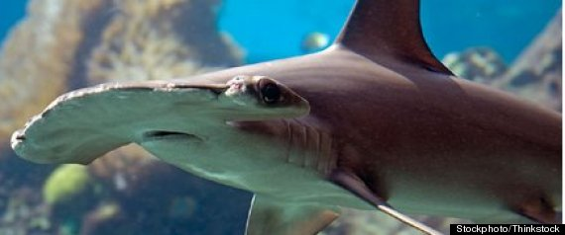
Among sharks, the bonnethead, the blacktip shark, and the zebra shark can reproduce through means of Parthenogenesis. 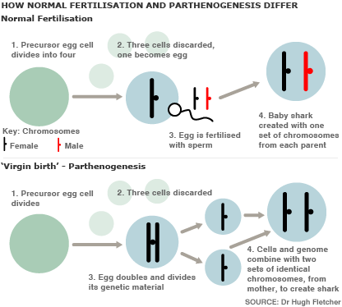
If the Parthenogenetic offspring uses the XY chromosome system, the offspring will have two X chromosomes (XX) and will be female. If the Parthenogenetic offspring uses the ZW system they could have a two Z chromosomes (male), two W chromosomes (non-viable or rarely female) or a Z and a W chromosome (Female).

