How to encourage wildlife into your garden 1
There is more wildlife to see. There are ways love nature even more and see wildlife more. The most obvious way to encourage wildlife is to get bird feeders. They are not expensive and can be hung up anywhere. There are different bird feeders for finches than tits. Finch feeders have small round holes in plastic tubes and tit feeders have metal quadratic sides. It will take a while though for birds to notice your feeders and then feel safe to eat from them. I have dozens of different types of birds on my feeders including goldfinches, greenfinches and long tailed tits. Here is a photo of my Goldfinch feeder.
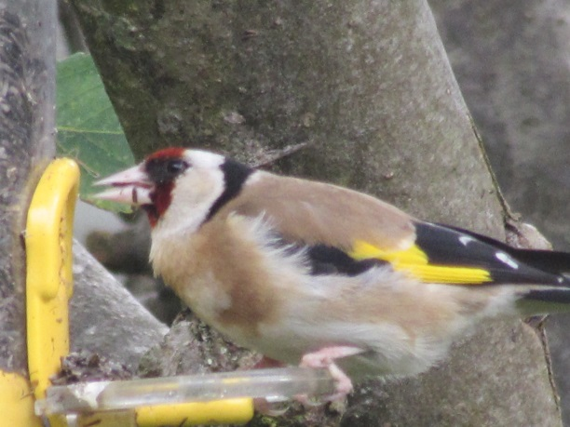A pond is very useful. And I mean VERY useful and amazing. Imagine frogs, dragonflies, toads and newts in your garden. Many frogs and toads are endangered because there are not many ponds around. I just pick up newts and hold them in my palm sometimes.
It is also useful to have piles of logs or rotting wood in your garden. They will attract stag beetles and toads. Possibly even Lizards!
If you would like Hedgehogs in your garden you will have to make sure that they can access your garden from the sides. You should make a way of them getting through the fence if you don’t have any entrances.
I will write a lot more on how to encourage wildlife. This is just a summary on what you can do. This is a common toad in some rotting wood in my Garden. Just remember…If you build it, they will come.
